

Project ID

30

A

Project Report On

WeTube

Submitted in the Partial fulfillment of the requirement for awarding the degree of Bachelor of Computer Application (BCA)

SEM VI, Year 2024-25

By

**Chotai Saloni (003303221001)**

**Dhandhukiya Mansi (003303221282)**

*Under the Guidance of*

**DEPARTMENT OF COMPUTER SCIENCE**

LATE P.S. HIRAPARA MAHILA BCA COLLEGE JETPUR

Affiliated to

SAURASHTRA UNIVERSITY - RAJKOT

## Preface

This report contains all the outputs of a project undertaken to develop a working model of _________________________and to study the existing working system. As part of this study, we analyzed the requirements of the working model and tried to improve it using the technological functionality that the current computer science provides.

This volume contains the documentation summary of the working system, the background study and analysis, the technical requirements and the working specification of the developed system.

We recommend the user to take the advantage of the study presented here and implement the system with their required improvisation. We hope this study will reduce the burden of the reanalysis of the development phase.

## Acknowledgment

“It is not possible to prepare a project report without the assistance & encouragement of other people. This one is certainly no exception.”

On the very outset of this report, we would like to extend our sincere & heartfelt obligation towards all the personages who have helped us in this endeavor. Without their active guidance, help, cooperation & encouragement, we would not have made headway in the project. We are ineffably indebted to our HOD / Prof. Jitendra Kabariya for conscientious guidance and encouragement to accomplish this assignment.

We are extremely thankful and pay our gratitude to our project guide Prof. ……… his/her valuable guidance and support on completion of this project in it’s presently.

We extend our gratitude to Department Of Computer Science, Late P.S. Hirapara Mahila BCA College-Jetpur for giving us this opportunity.

Thanking You

Chotai Saloni (**003303221001**)

Dhandhukiya Mansi (**003303221282**)

**INDEX**

|  |  |  |  |
| --- | --- | --- | --- |
| * **Front Page** | | | |
| * **Certificate** | | | |
| * **Preface** | | | |
| * **Acknowledgement** | | | |
| Sr. No. | Title | | Page No. |
| **1** | **Project Profile** | |  |
|  | 1.1 | Project Definition |  |
| 1.2 | Scope |  |
| 1.3 | Objective |  |
|  | 1.4 | Technical Description |  |
| **2** | **System Analysis and Specification** | |  |
|  | 2.1 | Study of Current System |  |
| 2.2 | Weakness of Current System |  |
| 2.3 | Introduction of New System |  |
| 2.4 | Hardware and Software Requirement |  |
| **3** | **System Requirement Specification** | |  |
|  | 3.1 | Proposed System and Advantages |  |
| **4** | **System Design** | |  |
|  | 4.1 | Use – case Diagram |  |
| 4.2 | Data Flow Diagram |  |
| 4.3 | E-R Diagram |  |
| 4.4 | Data Dictionary |  |
| **5** | **Screen Design** | |  |
| **6** | **Testing (Manual, Test Cases and Test Data)** | |  |
|  | 6.1 | Manual Testing |  |
| 6.2 | Test Cases |  |
| **7** | **Enhancements** | |  |
|  | 7.1 | Advantages |  |
| 7.2 | Limitation |  |
| 7.3 | Future Scope |  |
| **8** | **Bibliography** | |  |

**1.Project Profile**

* 1. **Defination :-**
* WeTube is a video sender and video viewer application.
* Wetube work like youtube.
  1. **Scope :-**
* Your videos share on Wetube after login.
* User can see and search all videos without login and registration.
* You can download video after login.
* You can see your history and clear this.
* You can easily watch videos and like and comment on the Wetube website.
  1. **Objective :-**
* Our theme is meant to entertain and de-stress people.
* You can also view the website without logging in to the Wetube website.
  1. **Technical Discription :-**

* Front End :-

HTML , CSS , Java Script

* Back End :-

Python , SQLite

**2.System analysis and specification**

**2.1 Study of current system (need to new system) :-**

* Wetube is a website where you can upload your videos and save the videos you like.
* For the entertainmenet of young,children and youth and the elderly.
* This website is designed to watch different videos at home.

**2.2 Weakness of current system (problem analysis) :-**

* 1. **Introduction of new system :-**
* Wetube is a video sending and video downloading website.
* Users can watch videos without registering, can like, and can also comment on videos.
* User can register and post their own videos on the website.
* Young, old and all can watch videos from the WeTube website.
  1. **Hardware and software requirement :-**
* **Feasibility study :**
* Feasibility study give the idea about our software that file it is feasible to developed project within such type of tools. it is a one type of measurable for measured our project.
* There are three main factor with determines the feasibility of the project are:

(1)Technical feasibility

(2)Economic feasibility

(3)Operational feasibility

1. **Technical feasibility :**

* Project is technical feasibility here the study of available resource.
* **Hardware requirement**

|  |  |
| --- | --- |
| **Category** | **Subcategory** |
| Processor | Intel pentinumdual |
| Mother board | P61 compatible with the processer |
| Hard disk | 250 GB or more |
| RAM | 1 or 2 GB |
| Monitor | Any CRT LCD/LED |
| SMPS | 450 watt |
| Keyboard | Any multimedia |
| Mouse | optical |

* **Software requirement**

|  |  |
| --- | --- |
| **Category** | **Subcategory** |
| Front end | HTML , CSS , Java Script |
| Back end | Python , SQLite |
| Browser | Any web browser(chrome, Mozilla Firefox) |
| Operating system | Cross platform |
| Server technology | Window server |

1. **Economical feasibility :**

* This system conduct cost to full system investigation.
* **Hardware requirement:-**

|  |  |  |
| --- | --- | --- |
| **Hardware** | **Subcategory** | **Price** |
| Processer | Intel core i3 10th gen | 6800/- |
| Mother board | GA H61m d2-b3 | 3000/- |
| Hard disk | 250 GB or more | 3400/- |
| RAM | DDR3(3 GB) | 500/- |
| Monitor | De11 18.5 LED | 6200/- |
| SMDS | Circle 450 watt | 1200/- |
| Keyboard | Logitech wire keyboard | 750/- |
| mouse | Logitech optical | 550/- |

* **Software requirement:-**

|  |  |  |
| --- | --- | --- |
| **Software** | **specification** | **price** |
| Front end | HTML , CSS , Java Script | 1999/- |
| Back end | Python , SQLite | 8000/- |
| Browser | Any browser | Free |
| Operating system | Microsoft windows 10 | 4800/- |
| Server technology | Window server 12 | 3000/- approx. |

**3. Operational feasibility :**

* User can use this website in any browser.
* User can create his account and send his video in this website.
* User can watch video even without login.

**3. System requirement specification**

**3.1 Project model :-**

* **User :**
* **Registration :**

* User can create new account.
* Users can register on the website by filling up the registration form.
* **Login :**
* User can login and logout.
* **Home :**
* A home page is the main web page of a website.
* **Contact us :**
* A contact us page provide guidance for existing customer and offer an overview of your brand few new visitors.
* **About us :**
* This page is information of the about us.
* **Comment :**
* User can give the comment of videos.
* **Liked videos :**
* Users can like the video they like.
* **Delete videos :**
* Users can delete videos that they don't like.
* **Showing videos :**
* Users can watch videos even without registering in the website.
* **Change profile :**

* User can edit their profile.

* **Change password :**
* Change the password. regularly updating your password.
* **History delete :**
* User can delete the history of searched videos.
* **Logout :**
* User can logout from the website.
* **Admin**
* **Login :**
* Admin can be login and logout.user can login and logout.the login page allows a user to access a website or web application by entering their username and password or by authenticating with a social network login.
* **View registration :**
* The user shows the registration done in this website and the user registers himself.
* **View comment :**
* A user views the videos they have watched and given their thoughts.
* **View liked videos :**
* The video is placed on the website, the user likes the video and views it.
* **View saved videos :**

**4. System Design**

**4.1 Use Case Diagram :-**

* **User :**



* **Admin :**



**4.2 Data Flow Diagram :-**

* The symbols that are used the data flow diagram carry following meaning.

|  |  |  |
| --- | --- | --- |
| **Symbol** | **Name** | **Use** |
|  | **Rectangle** | It symbolizes the source of inputs the data. |
|  | **Circle** | It is represented by a circle and depicts how the data in handled and processed in the system. |
|  | **Un Marked line** | It is represented by a circle and depicts how the data in handled and processed in the system. |
|  | **Marked line** | It is represented by directional lines and depicts the flow data from one location to another. |
|  | **Round rectangle** | It symbolizes the data flows are the inputs and outputs of the dfd. |

* **0- Level DFD :**



* **1- Level DFD :**



**4.3 E-R Diagram:-**

**4.4 Data Dictionary :-**

**5. Screen shot**

* **Registration Page :-**

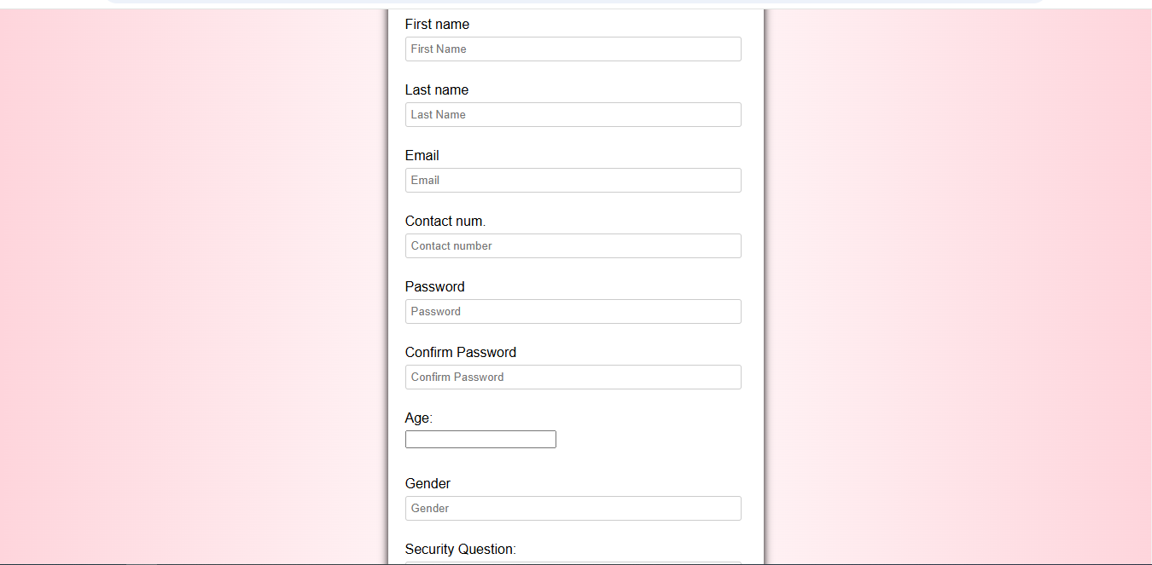

* This is a registration page.
* This registration step requires the user to enter the website by filling up the required fields.
* Finally you can enter the website by clicking on the register button.
* **Login Page :**

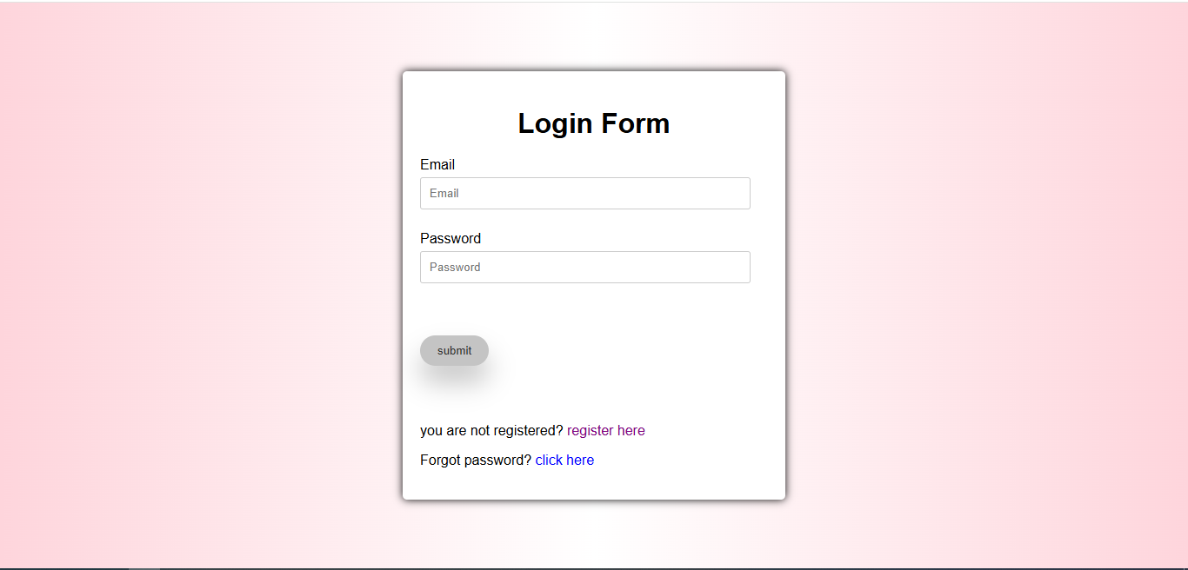

* You can login to the website by filling the email id and password in this step.
* You are given 2 links which are Register and Click Her Means Forgot Password.
* Clicking on the Forgot Password link opens the Forgot Password page.
* **Home Page :-**

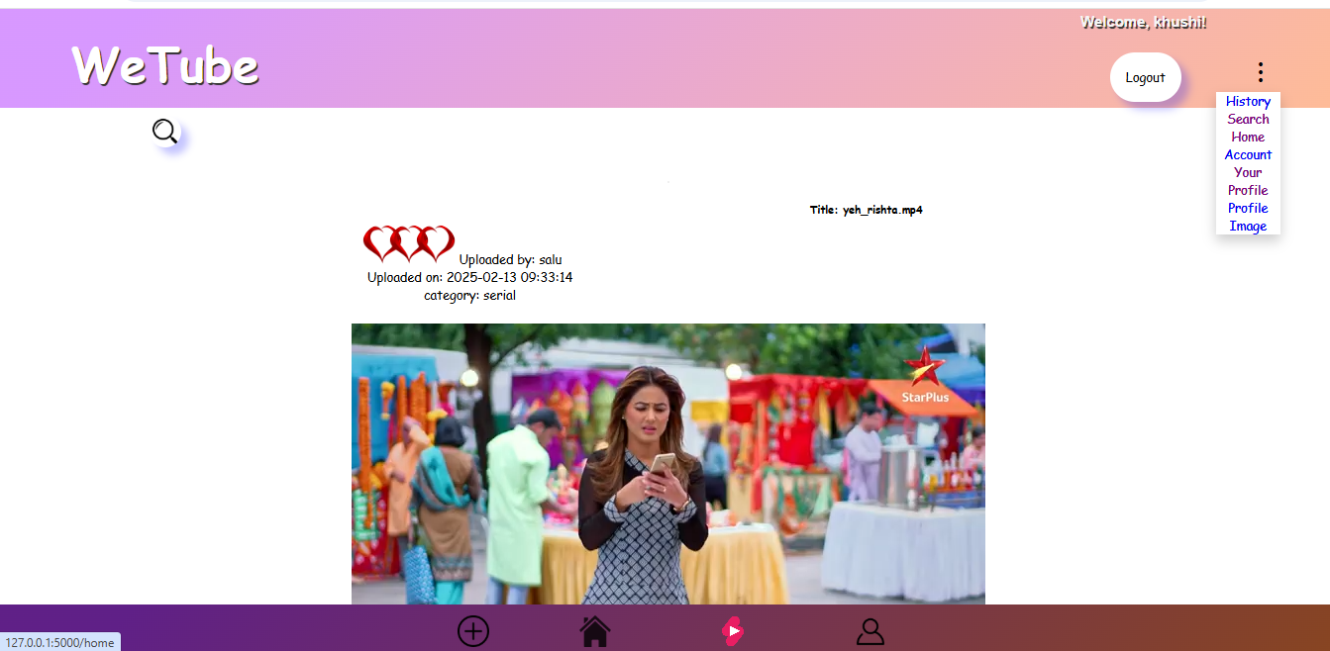

* This step leads to the home page of the website.
* There are four icons in this step which are to add a video, to go up to the home step, to watch a short video, and to go to your account.
* A search button is provided in the corner.
* Three dot menu is provided to redirect to History, Search, Home, Account and About footer.
* **Upload Video Page :-**

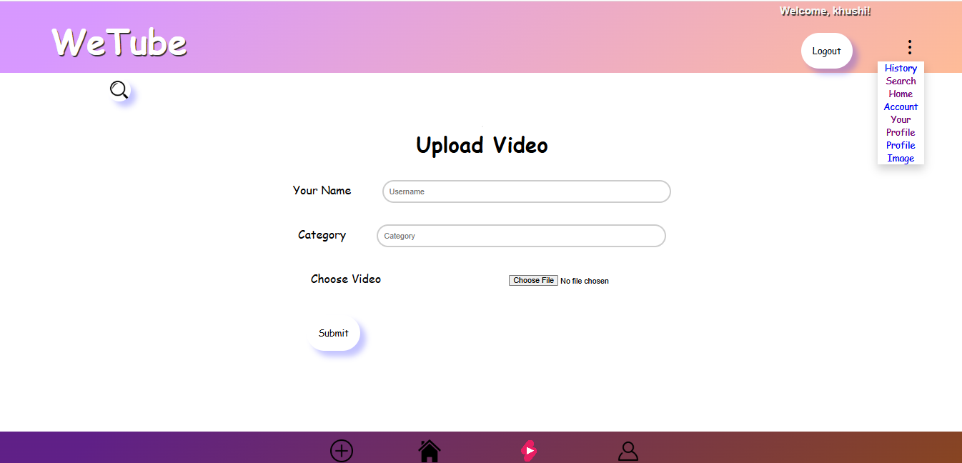

* this are page is video upload page.
* To upload your video you have to enter the category of source and video.
* For uploading video you are given another fill no option so that you can extract video from other folder.

* **Account Page :-**

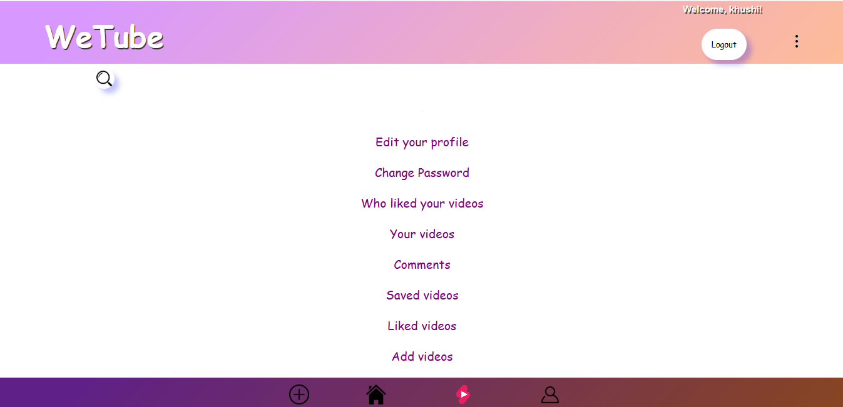

* This page is the account page.
* The account provides many options.
* Edit profile option to edit your profile.
* Change password and no option to watch your uploaded videos.
* These two options are provided to view your comment video and the likes someone has made in your video.
* You can be redirected to add video from add video option.
* **Change Password Page :-**

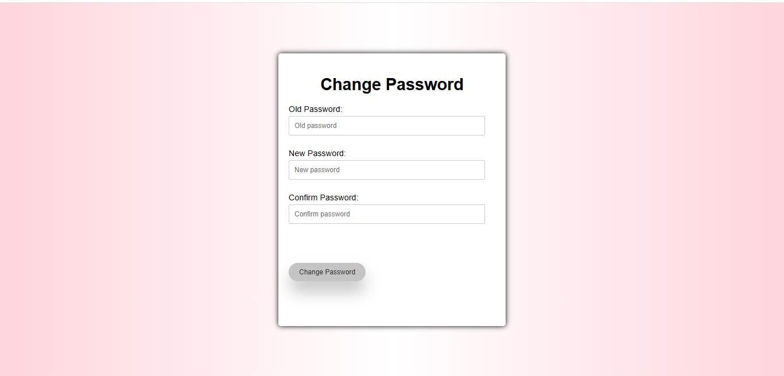

* This page is the change password page.
* You can change password by entering your old password and new password and confirm password.

* **Edit Profile Page :**

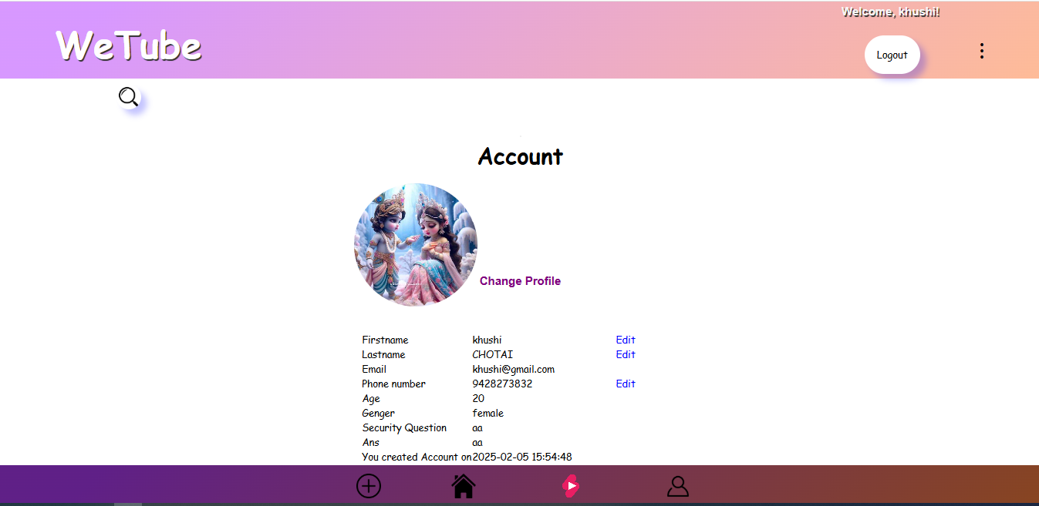

––––--–

* This is the account page of website.
* The edit profile step contains all the details of the user and the user can also upload these details.
* Show profile image

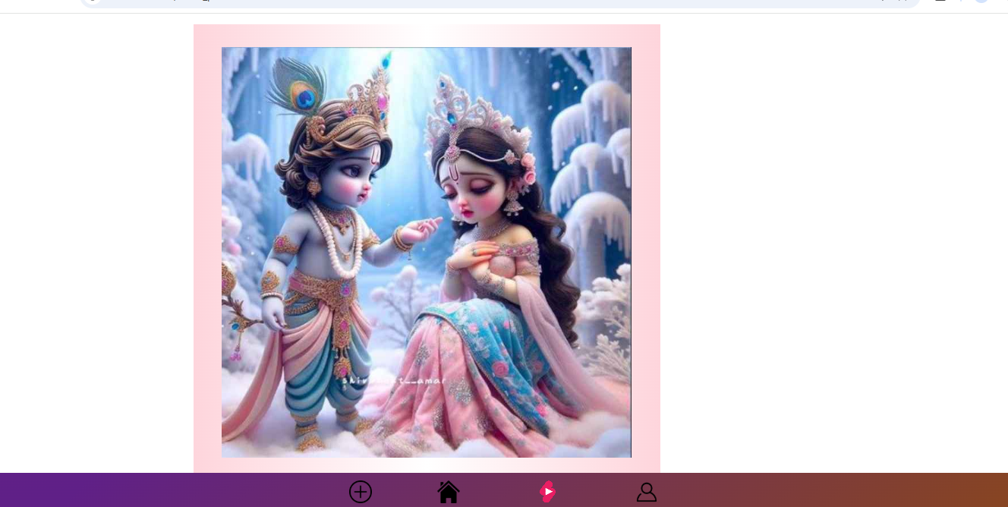

* Click on your profile image and ,
* You can see your profile image like this.
* View all comments page:

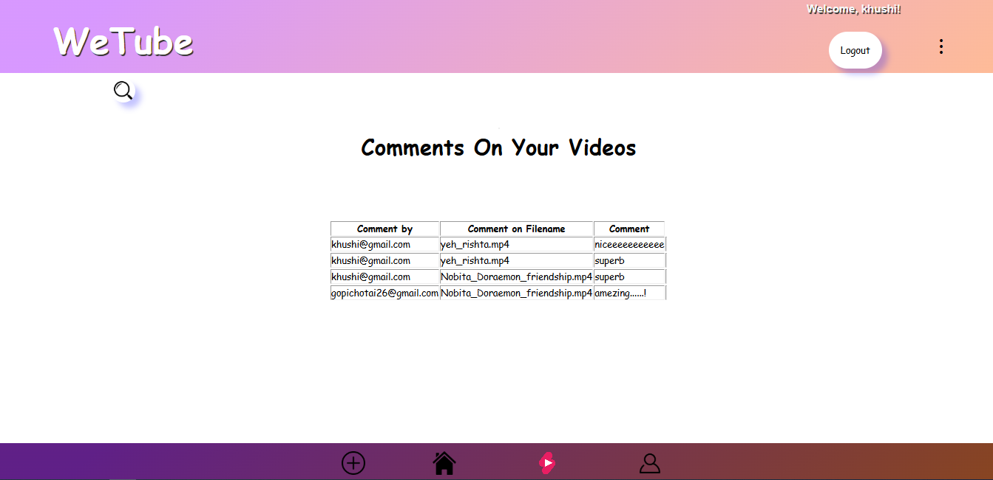

* This page is show comments
* When user comment on your video ,You can see your uploaded video comments in this page
* Search page:

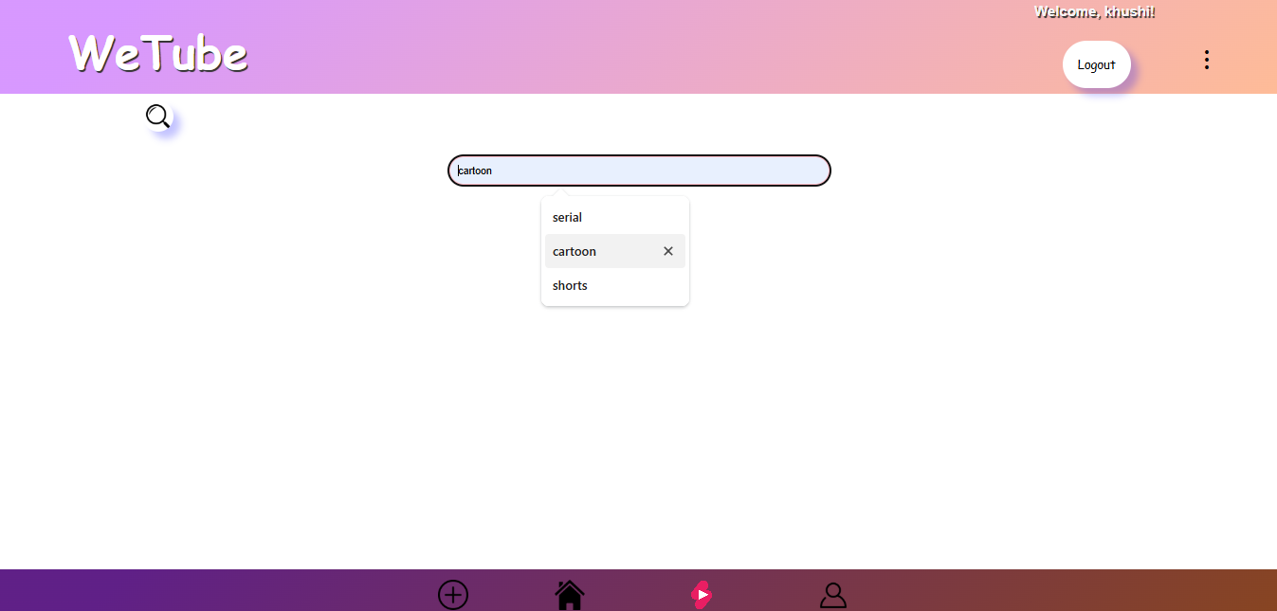

* You can search videos in search page.
* Your videos page , Save video page , Liked video page

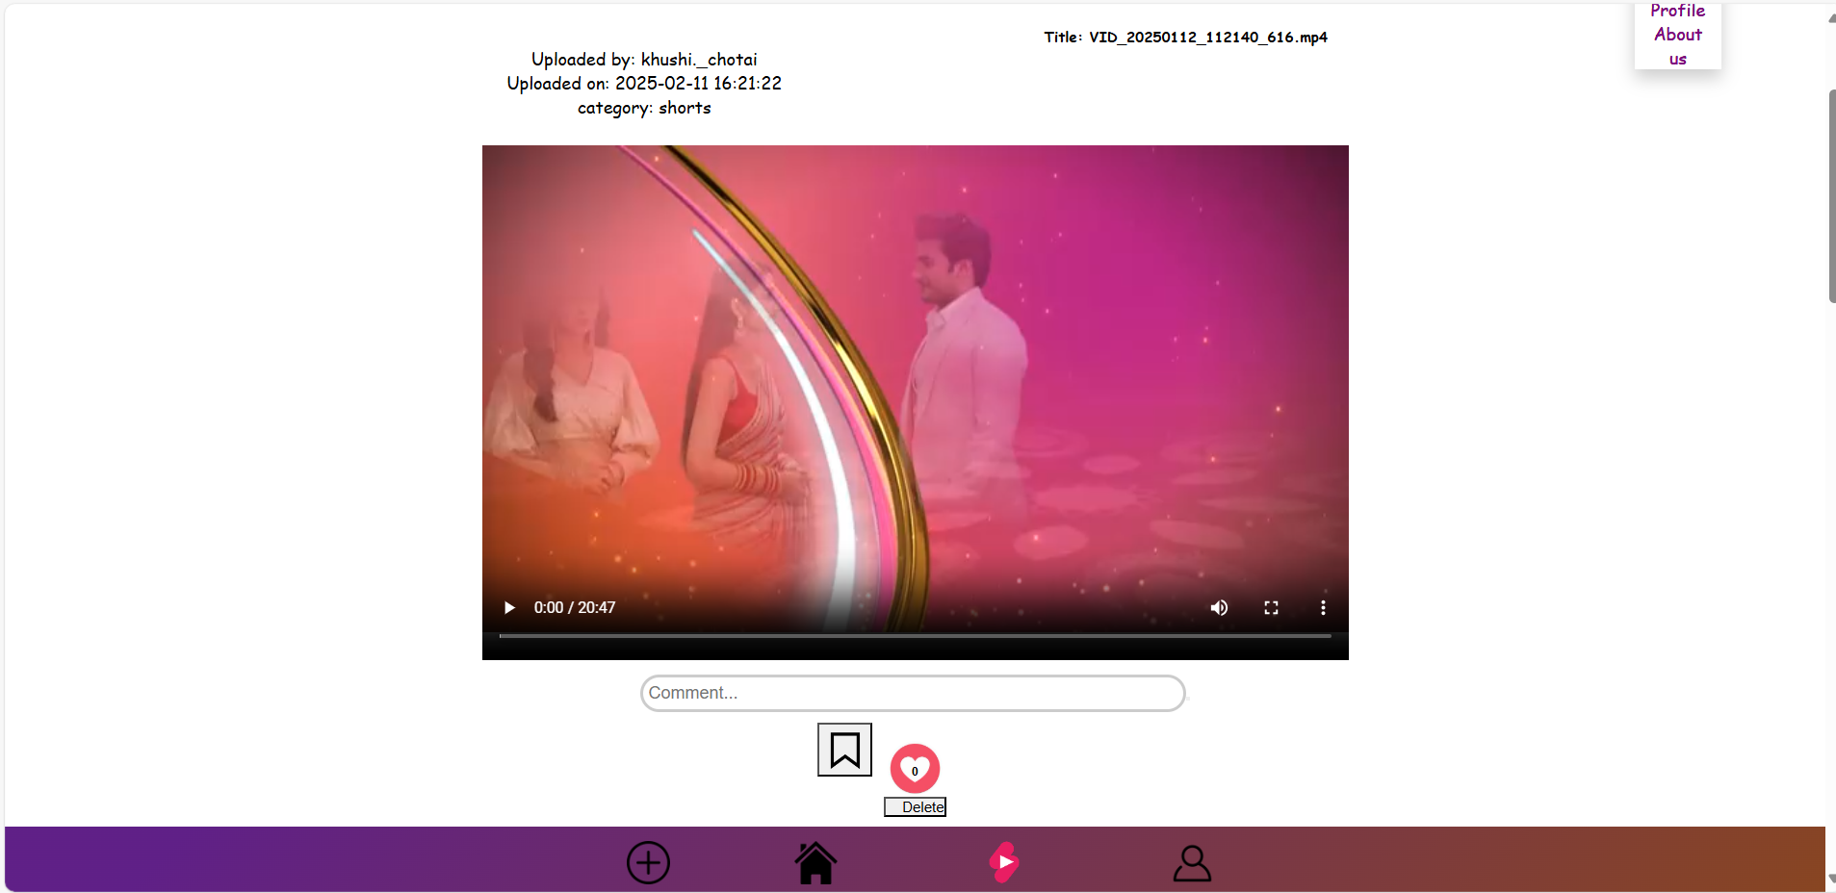

* Your video page show your uploaded all videos.
* You can delete your uploaded video in your video page.
* Save video page will show your saved video(save watch later).
* You can unsave video on your save video list after you watched saved video.
* Liked video page will show your liked video.
* View comment page:

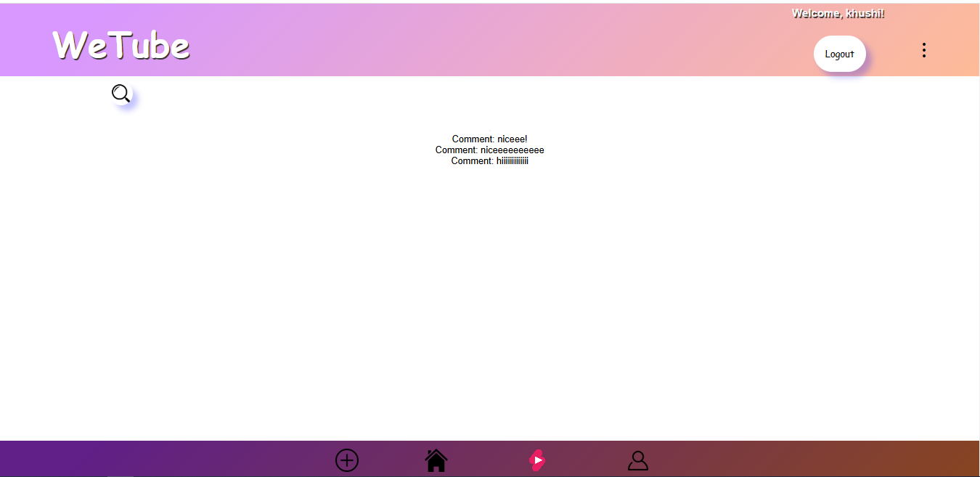

* When you enter your comment ,
* This page will show all comments that video.

* Edit first name :

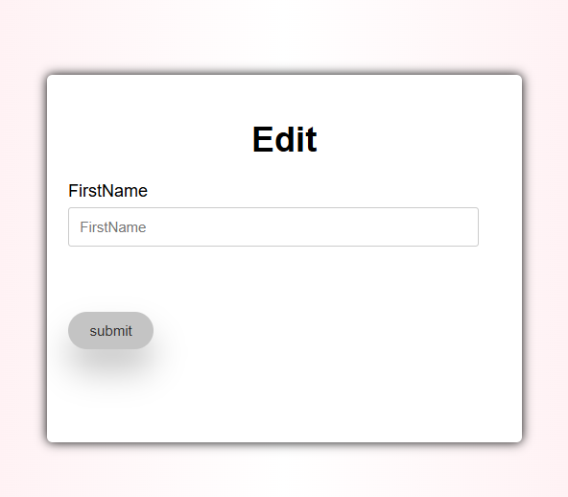

* This is a edit page.
* You can edit your first name.
* Edit last name :

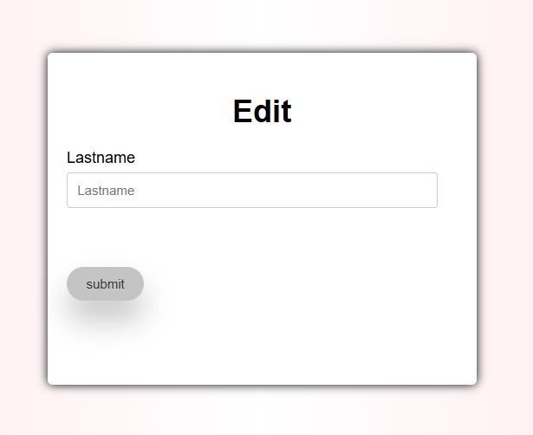

* This is a edit page.
* You can edit your last name.
* Edit phone number:

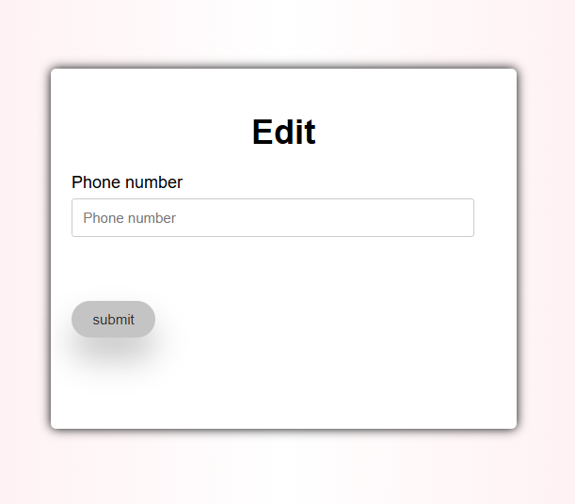

* This is a edit page.
* You can edit your phone number.
* Admin Home page:

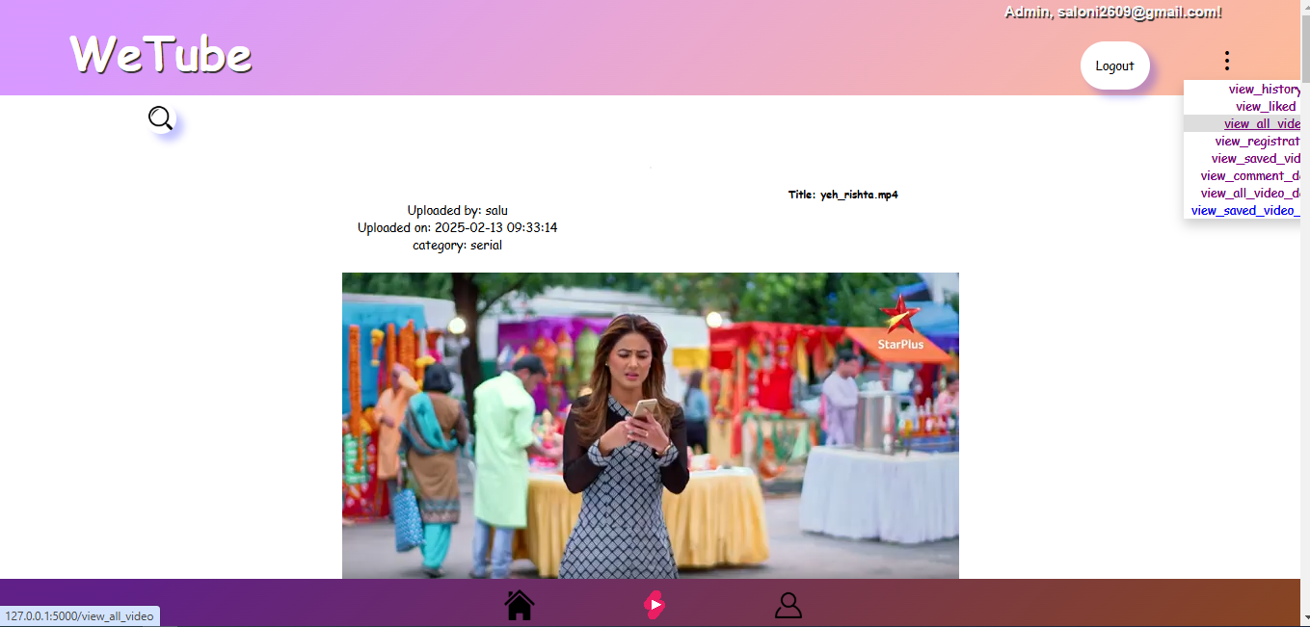

* This is a Admin home page.
* Admin can see all videos.
* And admin can delete any videos
* View Registration Page:

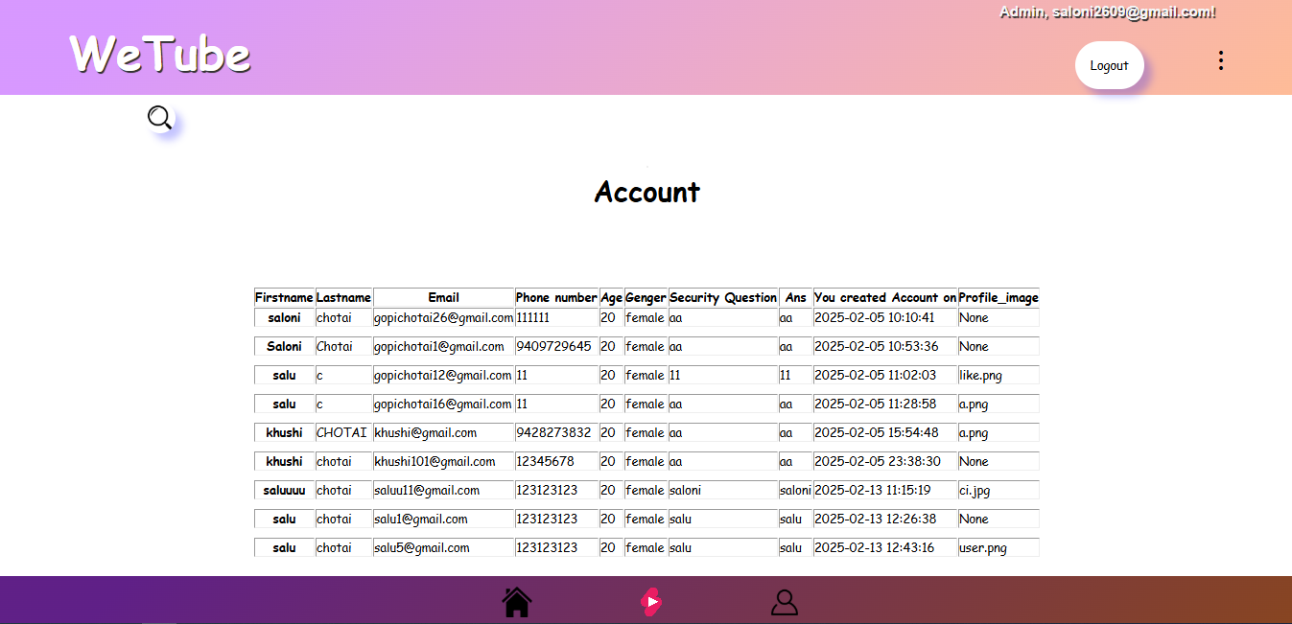

* This is a View registration page.
* Admin can see all registration details.
* View Comments Details Page:

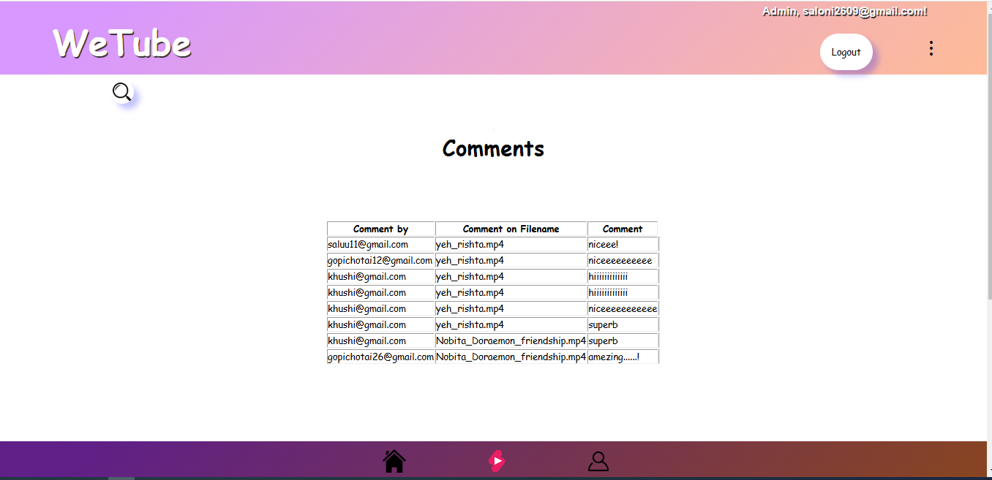

* This is a View comments page.
* Admin can see all comments.
* View all video detail:

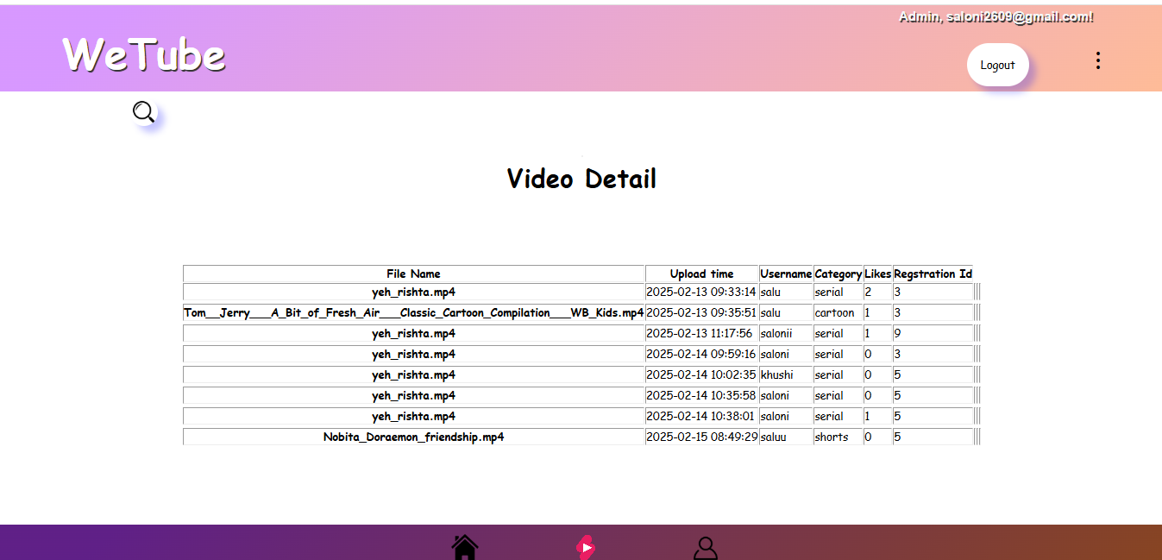

* This is a View all video page.
* Same as home page.
* View all saved video detail:

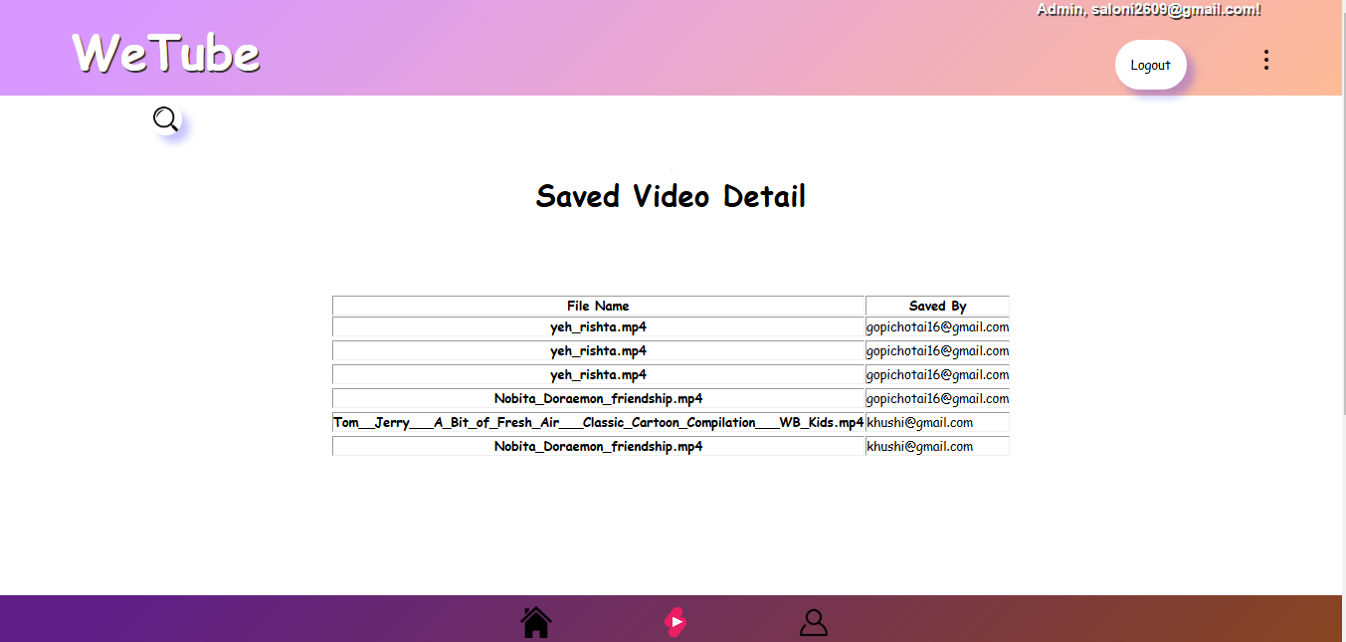

* This is a view saved video page.
* Admin can see all comments.

* Forgot password: Step-1:

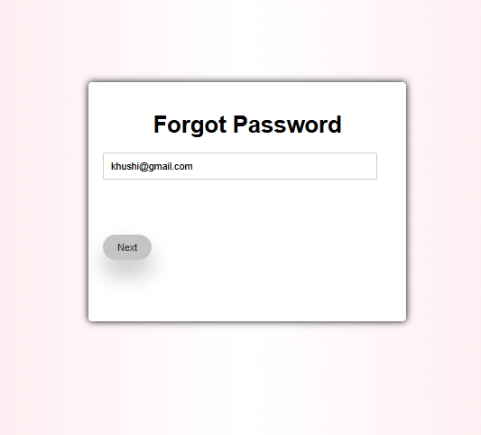

* This is a Forgot password page.
* You can change your password when you forgot your password.
* This is a first step .
* You enter your email and next.
* Forgot password: Step-2:

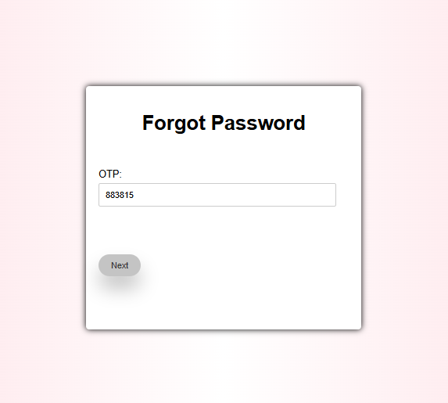

* This is a Forgot password page.
* You can change your password when you forgot your password.
* This is a second step .
* Now , your OTP is generated automatically and next.
* Forgot password: Step-3:

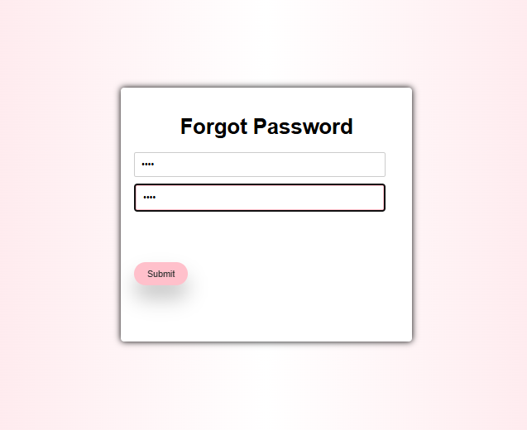

* This is a Forgot password page.
* You can change your password when you forgot your password.
* This is a third step .
* Now , enter your new password.
* You can login successfully with your new password.

**6. Testing(Manual, test cases and test data)**

* **Manual testing :-**
* **What is testing?**

Software testing can be used stated the process of verifying and validation whether a software or application is bug-free, meets the technical requirements as guided by its design and development and meets the user requirements effectively and efficiently by handling all the exception and boundary cases.

The process of software testing aims not only at finding faults in the existing software but also at finding measures to improve the software in terms of efficiency, accuracy and usability.

* **Software testing can be divided into two steps:-**
  + - 1. **Verification: -** it refers to the set of tasks that ensure that the software correctly implements a specific function.
      2. **Validation: -** it refers requirements to a different set of tasks that ensure that the software that has been built is traceable to customer.
* **What are the different types of software testing techniques?**

Software testing techniques can be majorly classified into two categories:

* + - 1. **Black box testing:-**the technique of testing in which the tester doesn’t have access to the source code of the software and is conducted at the software interface without any concern with the internal logical structure of the software is known as black box testing.
      2. **White box testing:-**the technique of testing in which the tester is aware of the internal workings of the product, has access to it source code, and is conducted by making sure that all internal operations are performed according to the specification is known as white box testing.
* **What are different levels of software testing?**

Software level testing can be majorly classified into 4 levels:

* + - 1. **Unit testing:-**A level of the software tests process where individual units/components of a software/system are tested. The purpose is to validate that each unit of the software performs as designed.

* + - 1. **Integration testing:-**A level of the software tests process where individual units are combined and tested as a group. The purpose of this level of testing is to expose faults in the interaction between integrated units.
      2. **System testing:-**A level of the software tests process where a complete, integrated system/software is tested. The purpose of this test is to evaluate the system compliance with the specified requirements.
      3. **Acceptance testing:-**A level of the software tests process where a system is tested for acceptability. The requirements and access whether it for delivery.
* **Problem analysis:-**

1. **Enhancements**

* **Advantage :-**

* Maintain whole system through one admin.
* No extra supported staff needs.
* Less expensive.
* Power full searching.
* Easy to use for all user.
* Routing work is done more effectively is less time.
* Can entertain your mind anytime.
* It is useful for users to learn new activities and new things.
* **Limitation :-**
* Users can no edit in application.
* Replacement facility is not available.
* **Future scope :-**
* We want to do following enhancement in projects.
* Some of limitation by using some advance technology in future.
* Remainder facility will be providing to user and admin.
* I will try to better facility of our site.
* Videos connect better with the audiences. Interestingly, consumers continue to choose video over other types of content, and videos are surpassing all other content forms when it comes to the ‘engagement’ criterion.
* There are also adding feature are provide to admin, so functionality of working will becomes fast.

**8.** **Bibliography**

* **Books :-**
* YouTube channel book
* Make YouTube work for you book
* Digital video book
* **Website :-**
* [**www.google.com**](http://www.google.com)
* [**www.youtube.com**](http://www.youtube.com)